A campaign for
VERDAMMNIS
WWII WEIRD ADVENTUREs

Version 1.0
By Eric LAURENT and DAWGIE

- PROLOGUE -

PART 1

« Endless life »

EGYPT, July 1937 :

The sun was high in the sky and Hauptmann Hans MULLER sweat under his SS uniform. “Dammed Country ! No radio, no women, not even a cool beer to quench my thirst”, he thought.

The sounds of picks and shovels echoed through the valley as the fellahs were digging the sand under the supervision of the german officer, responsible for the SS archaeological team.

Suddenly, Ahmed heard a metallic noise as his shovel bounced on a rock : he was sure : the tomb was there, just a few feet under the ground. He immediately called Hauptmann MULLER : “ I found something, Saïb”.

The fellahs redoubled their efforts to unearth the non descript Egyptian tomb they were looking for since six weeks.

By the end of the day, the entrance of the tomb was unearthed. Hauptmann MULLER was the first to enter the stone door, followed by Ahmed and Aziz. He walked in the dark and fresh corridor, a gas lamp in his right hand. The crypt must be close to him now.

As he walked through the corridor, he bumped on something : two skeletons were lying on the ground, their skulls crushed.

The walls of the crypt were decorated with a painting of a human figure, hands raised in a threatening posture, eyes fixed in an evil gaze. Inside its gaping mouth was the body of another human.

Another picture appeared to be sculpted on the wall and showed the victim lying on his deathbed and rising up again to bite another man.

Thousands of scratch marks adorned every surface inside of the tomb, as if someone had tried to claw its way out.

As he explored the crypt, Hauptmann MULLER found a strange corpse partially decomposed outside an empty sarcophagus. The body itself had several bite marks on the right radius.

As he tried to examine the corpse closer, the corpse rose to grab the officer’s arm.

Hauptmann MULLER tried to grab his Lüger, but the holster was empty : he had forgotten to take his pistol in his tent. He now had no choice than to run as fast as he could to escape this nightmare creature, just like Ahmed and Aziz did, as they already were running like rabbits through the dark corridor…..

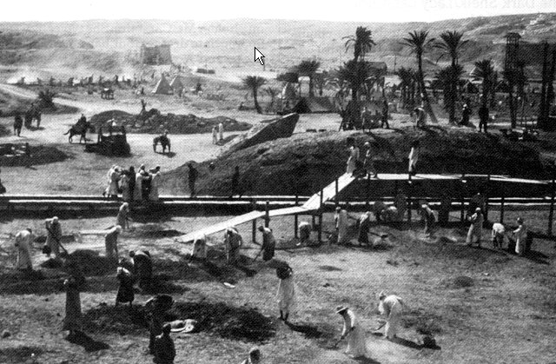

THE GAME :

Tabletop 60 x 60 cm

TEAM A :
1 german soldier with Lüger
6 egyptian workers with picks and shovels

Objective : kill the zombie

TEAM B :
1 zombie

Objective : eat !!!!!!

PART 2

« An unexpected incident »

GERMANY, September 1937 :
The cryogenic glass tanks dressed a long line in the laboratory where Manfred was working as biologist. Each one was maintening a dead corpse in stasis.
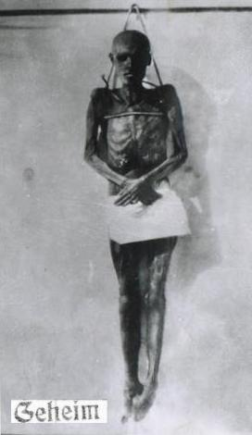
He had conducted an autopsy and several experiments on the corpse found in Egypt and discovered that it was infected by an unknown virus (named W virus by the scientist) which could sustain human life and revive the dead.
He had succeeded in bringing dead soldiers back to life but with major brain damages. These undead soldiers were nicknamed “Wiedergänger” by his colleagues.
They would soon join the special military division specially created to regroup them.
All was quiet in the laboratory tonight : Manfred’s assitants were sleeping in the next room and the two guards at the entrance were surely drunk as usual. The scientist could write his speech : tomorrow morning Colonel KRIEGER would visit his laboratory and admire his work.
The Nazi scientist’s desk was encumbered with papers of all sorts : reports, analysis, notes and memos. As he was engrossed on his work, Manfred didn’t notice the red light warning that tank K41 was malfunctionning. The temperature was increasing and the valve maintaining a constant temperature was steaming. The top of the tank violently opened to free the terrible creature.
Manfred felt a strange presence in his back. He just had enough time to push the alarm button before the creature grab his head and bite his throat.
The horrible scream yelled by Manfred awaken his assistants.
As the guards enterred the laboratory, 20 red lights were flashing…..
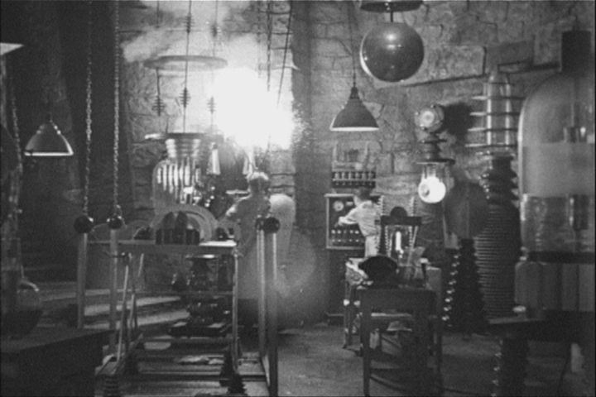

THE GAME :

Tabletop 120 x 120 cm. A german laboratory and some buildings.

TEAM A :
2 german soldiers with MP40
4 scientists with Lüger
Objective : kill the zombies

After 1D6 turns, german reinforcements will arrive : 3 soldiers with KAR98 and one leader with MP40

TEAM B :
20 zombies

Objective : kill the humans

- Scenario I -

« Breaking the habit »

FRANCE, Normandy, ARDOUVAL, August 1944 :

Lieutenant WATSON of the Royal Commandos was used to this kind of mission : his team was one more time dropped behind ennemy lines at night near the objective.

Tonight it was an easy task : blow a V1 ramp hidden in the forest and come back home.

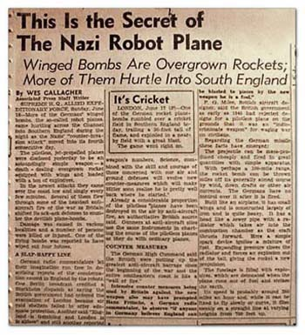
“ Piece of cake” he thought as he was observing the V1 site with his binoculars.

Only two guards were sittting and smoking a cigarette next to the ramp. The rest of the germans must be sleeping in the bunker.

Lieutenant WATSON adjusted the silencer to his Sten machine gun and waved his hand to call his men back. Mc KENZIE, the radio operator, was the first to arrive. They had successfully completed many missions together since Dday and the “BBC fellow” as he used to call him was ready to go once again.

WATSON asked him to approach the bunker to check the perimeter.

Mc KENZIE crawled silently through the trees and bushes. 10 meters, 5 meters, 2 meters……he was now right at the bunker’s corner, hidden by sand bags, and had a wide sight of the V1 ramp. All seemed quiet except a kind of scratchy choked noise approaching the bunker.

Mc KENZIE couln’d see what it could be : he slowly grabbed his combat knife, raised and glanced over the sand bags. It couln’t be a human nore a machine : the massive and tall body was a mass of muscles and metallic parts wearing a german helmet. More than two meters above, his red glowing eyes were watching Mc KENZIE.

The commando tried to run but the giant fist bashed him to the ground.

Fortunately, he was still alive but the radio was smashed : how could the team go back to the base ?

THE GAME :

Tabletop 120 x 120 cm.

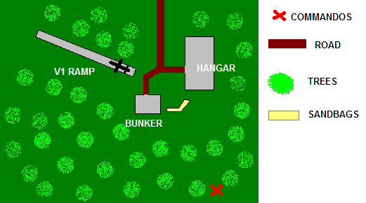

TEAM A :
1 german officer
8 german soldiers
1 Ubersoldat

Objective : kill the ennemy
TEAM B :
12 Britsh Commandos

Objective : destroy the V1 ramp with shape charges and fallback

- Scenario ii -

« On your own »

FRANCE, Normandy, ARDOUVAL, August 1944 :

The region was full of german flak guns and it was far impossible to estimate the duration of the mission.

The V1 ramp was blown but Mc KENZIE radio was also totally broken. How could he call the base for the extraction…the team was on his own now.

Lieutenant WATSON examined the map : the german radio station was not too far : only 2 miles. The lieutenant and the survivors of his team had no choice but to raid the german radio station to call the base and hopefully find a mean to go back home…

THE GAME :

Tabletop 120 x 120 cm. A german radio station in the middle of the forest.

TEAM A :
8 german soldiers

Objective : protect the building and kill the ennemy

TEAM B :
12 British Commandos (or only survivors from previous scenario)

Objective : take control of the building

- Scenario iii -

« A long way home… »

FRANCE, Normandy, ARDOUVAL, August 1944 :

“ The bird will pick you up in one hour ” said Major REED.

“Roger, over” answered Lieutenant WATSON before smashing the radio with the butt of his machine gun.

The british commando team headed to the extraction point.

Suddenly, the silent of the night was broken by the familiar sound of the plane’s propellers. In one hour, Lieutenant WATSON could drink a cup of tea and have some rest.

“Bad day” he thought when the RAF plane was hit by the german flak and fell to the ground in a fireball.

The only solution was now to find a vehicle and drive through ennemy lines.

The commandos walked one hour by moonlight before reaching the first large village where they could have a chance to find a vehicle….

The main street was dark and quiet at this time of the night but the commando had to hurry as the sun would soon rise. A truck, an Opel Blitz, was parked near the church, in the center of the village. No german soldier seemed to guard it : the Royal Commandos couldn’t miss such an opportunity to flee this town. Lieutenant WATSON and his men advanced carefully, hiding behind each corner, ready to fight. He was sure he had heard something moving in the church.

A group of men was walking to the truck. WATSON recognised the typical german helmet. None of them seemed to be armed except the leader of the small group.

Sergent PETERSON, who was just behind the officer, stumbled.

“Was ist los ?” said one of the german soldiers as he pointed his MP40 in the direction of PETERSON.

Lieutenant WATSON didn’t hesitate one second and shot the leader right in the head.

Private REED opened fire too and two other soldiers fell to the ground. As the rest of the germans calmly advanced in the direction of the commandos while the fallen soldiers rose.

“What the hell” said REED, I am sure I shot them………

“I want to go back home” cried PETERSON.

THE GAME :

Tabletop 120 x 120 cm. A french town.

TEAM A :
4 german soldiers
8 zombies

Objective : kill the ennemy

TEAM B :
12 British Commandos (or only survivors from previous scenario)

Objective : steal the truck and leave the village

- Epilogue -

« Have nice holidays »

FRANCE, Normandy, COLLEVILLE-SUR-MER, nowadays :

July 12th : The two kids, Alain, Sebastien and Pierre, were playing together each day after school. Today they decided to go to their secret place. A few days ago, Alain found a hidden door in the forest. This door was covered by vegetation and no one had ever found it before : it was his treasure.

Alain loved to hide in this place and scare his friends, but today it was war : Alain and his friends brought their catapults. They opened the old door and began to go down the stairs. The corridor led to a large room in which all sorts of strange machines and rusted and forgotten barrels were stocked for a very long time. A inscription was written on one of the walls : “ Gefahr. Nicht Rauchen”. It must have been a german secret place during world war two.

The kids decided to shoot at the barrels with their catapults, imagining they were enemy soldiers. It was fun as the stones ricocheted on the barrels. They played for half an hour and went back home….leaving a leaking barrel behind them.

July 17th : All was quiet and the hotel was comfortable but John coulnd’t sleep tonight. It was too hot and he was thursty.
The young man and his friends, Brian, Julia and Kate were american students who came in France to visit Normandy. Kate’s grandfather was one of the soldiers who fought on Omaha beach on June 6th, 1944 and she wanted to visit Normandy, this famous place where so many men died : the american cemetery with its 9386 white crosses, the british cemetery with its 4648 graves, and the La Cambe german cemetery and its 21222 graves were here to remember it.

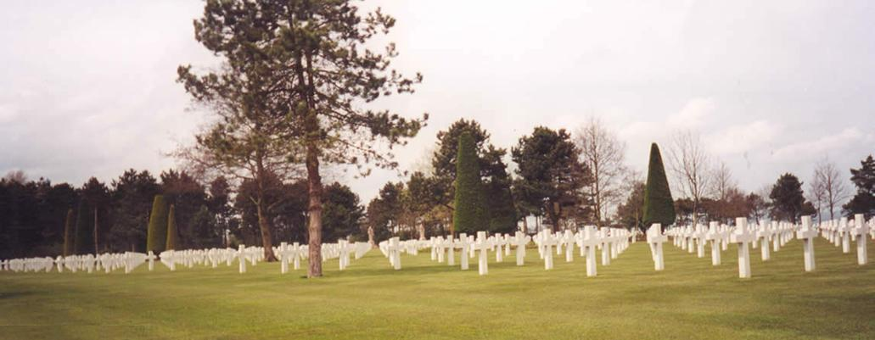

Today they visited the Normandy Battle Museum of Bayeux and the Saint Laurent Omaha museum. Tomorrow they would have rest, go to the beach and enjoy the sunny weather.

Suddenly, John heard a scream in the street. He ran towards the window and saw a woman running, followed by a horde of shadows.

John couldn’t let this women alone. He picked up his shirt and ran downstairs. As he opened the hotel main door he saw a silhouette in the street. John couldn’t believe it. It must have been a nightmare and he would awake in a few seconds : the zombie, dressed with the remains of a world war two uniform was walking in his direction, hands raised in a threatening attitude.

John just had time to slam the door……..he heard creatures moaning outside……….now he had to find a weapon and awake his friends….

THE GAME :

Tabletop 120 x 180 cm

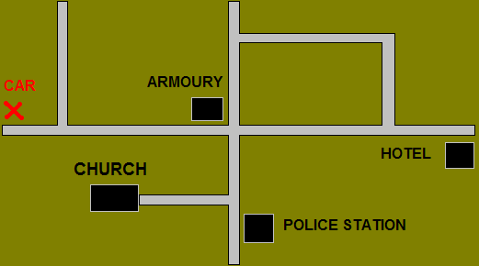

TEAM A :
4 students

Objective : find weapons, find a car and escape from town.

At the beginning of the game the students are armed with kitchen knives, a fire axe, clubs.

They will have to explore the town to find an armoury or a police station to find weapons. The armoury and the police station are in the middle of the town.

They can be helped by survivors (up to 4 survivors : 2 policemen in the police station, a man in the armoury and a priest in the church).

The car is at the opposite side of the table. When they reach the car, the players must roll 1D6 to see if the car starts :

D6 results :

1-2 : nothing happens….. the fuel tank is empty…we need gas…..(find gas I the town)
The gas station of the town is next to the hotel : they have to go back…

3-4 : the battery must be tired : roll again next turn

5-6 : it starts without any problem

TEAM B :
Thousands of zombies (they always attack the nearest target)

Objective : eat !!!!!!

This game can be played with a gamemaster and one or more players. In this case the following events can occur (but the players can’t guess them) :

* Keep in mind that the ammunitions are rare : you are in a small town, not a military base !!!

* John and his friends are looking for weapons in the hotel : all they could find is a fire axe, butcher’s knives and golf clubs. If they roll a 5 or 6 on a D6 they also find a pistol (with 6 bullets) in a desk.

* The players meet a priest in the church. He is armed with “faith and a cross”. He joins the group.The priest has been bitten by a zombie but he doesn’t tell it to the group. He will become a zombie in 1D3 turns.

* A man can assist them in the armoury and provide weapons. The students have to persuade the man to open the door by roll a CC test otherwise the man will shoot at them with a pump rifle.

* There are two policemen at the police station. Each are armed with a pistol (and 3 clips) and a pump rifle (and 30 cartridges). There is a police car but it is out of service due to a mechanical problem. The players don’t know it is not operable.

* Weapons can jam on a missed to hit dice roll.

* THE CAR : It is a pick up with only three seats. The other players have to go at the rear (open top). The car can speed up to 15 inches per turn.
Just set a second tabletop for the escape (120 x 180 cm). There might be barricades or wrecked cars on the road.

* Use your brain, not to feed zombies, but to imagine other events.

---

