A ScENARIO for
VERDAMMNIS
WWII WEIRD ADVENTUREs

Version 1.0

By Eric LAURENT and DAWGIE

« Neu-Schwabenland : Operation Highjump»

LONDON, December 1946 :

The briefing room was dark and foggy. Smoky should be more appropriate, as Colonel James B. Stuart was smoking a large cigar.

“Gentlemen, since 1945 there were many claims about alleged German developments of revolutionary saucer-shaped crafts able to fly with incredible performances”

“One of our spies, I won’t give you his name of course, took all the risks to bring photos and plans of a new german prototype flying craft which could change the face of the battle”.
“Our secret services called it a flying saucer but its german namecode is VRIL or V-7”

The photos of a circular object appeared on the white screen.

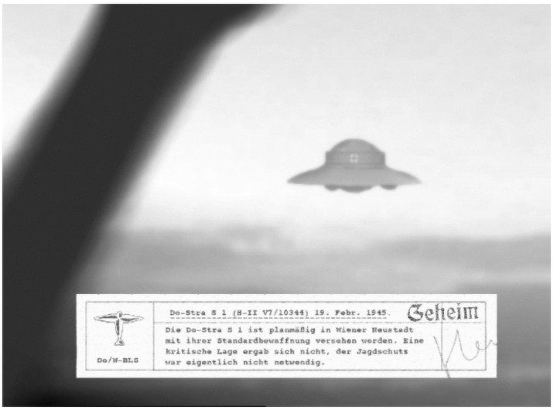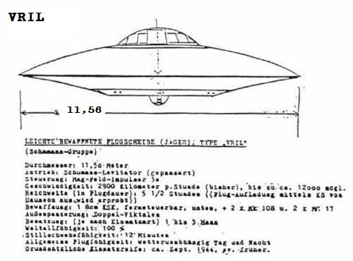

“According to our agent, the first tests of this flying object were led in Germany, under high protection as you can see on this photo.”

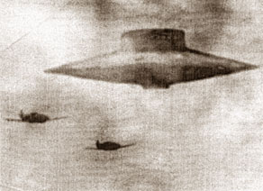
“Our Intelligence gathered enough informations to reveal that this flying saucer could be assembled in a nazi secret base situated in the Antarctic.”

“ The high command has decided to send a naval task force
to Antarctic. This operation is called "Operation Highjump”.

“Your mission is to find the underground base of the nazis in Neu-Schwabenland and destroy the secret installation for the sake of the world”.

A map of Neu-Schwabenland appeared on the screen.

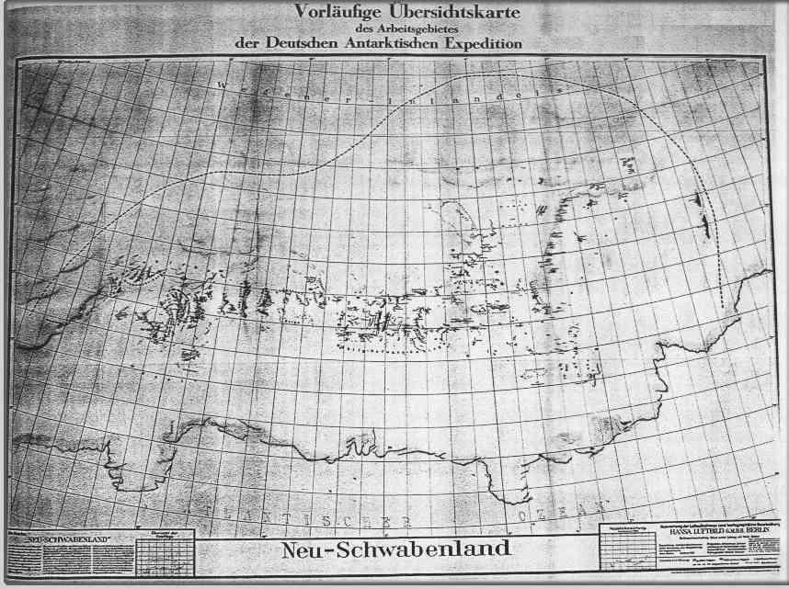

The british commandos, the paratroopers of the 101st Airborne and the russians soldiers left the briefing room to prepare for this new mission.

ANTARCTIC, January 1947 :

The british and russian commandos just landed a few minutes ago while the paratroopers of the 101st airborne were dropped on the site.

The vast and white territory was swept by icy and impetuous winds and the men couldn’t see anything else than snow.

Captain Clark pulled the map from his pocket and checked the position of his group. The secret nazi base should not be far now.

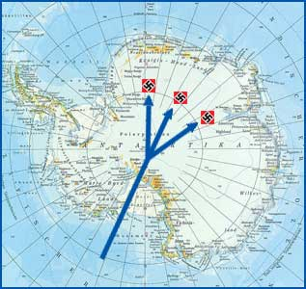

The secret facilities were hidden under a huge ice vault and only a few wooden shacks could be seen on the surface. Some smoke a dim lights indicated the position of this settlement. The group had to move towards his objective or the men would freeze in a few minutes. The men moved slowly in the dark….

THE GAME :

Tabletop 120 x 120 cm with the following buildings :

A few shacks : a central guard house, a technical shack (with a power generating unit providing heat and light for surface buildings), a supply shack, a small radio station with an antenna next to the guard house, a small garage for vehicles.

2 german tracked vehicles in the garage armed with MG42.

4 heated, snow covered, machine gun (MG42) bunkers to cover the approaches to the surface. Each bunker is connected to the central guard house by landline telephone (buried wires).

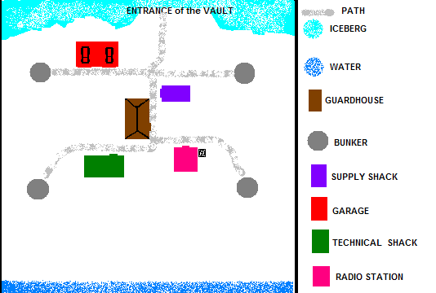

TEAM A :

24 allied soldiers (British, Americans or Russians)

Objective : kill the guards

TEAM B :

2 german soldiers in each bunker (total of 8 soldiers) but they don’t have any personnal weapon with them. Outside of each of the bunkers, beside the doors, is an unheated gunlocker where these weapons are left to prevent them from heating up, then “sweating” when taken outside into the antartic cold. There is a similar gunlocker outside the guard house for the same reasons.

2 german soldiers roaming from bunker to bunker on foot patrol. They are more concerned with keeping warm and not getting lost from the lifelines that link the bunkers to the guardhouse. These guys also provide personal relief and meal breaks for the bunker guys.
10 german soldiers sleeping in the guard house.

Objective : survive and give the alarm

If the alarm is given, german soldiers will call for reinforcements.

NOTES :

There is a telephone switchboard connecting to all other surface buildings as well as the subsurface command center in the guardroom.

At night, all surface buildings have external lights, as well as lifeline paths linking the buildings to keep the garrison from getting lost at night and during storms.

---

to be continued…..

