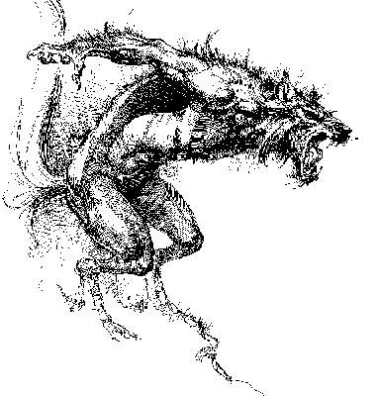

DOW
WEREWOLF

Version 1.0
By Eric LAURENT

These rules are a modification of DOW rules to play werewolves.

They are meant to be played with the DOGS OF WAR basic rules published by DEVIL DOG DESIGN.

InTRODUCTION

The word werewolf is a contraction of the old-Saxon word wer (which means "man") and wolf -- werwolf, manwolf. A Lycanthrope, a term often used to describe werewolves, however, is someone who suffers from a mental disease and only thinks he has changed into a wolf.

The werewolf superstition prevalent in late medieval Europe usually involved transformation of a human into a wolf under the influence of the full moon, nightly incursions into the woods to attack and eat animals and people, and regression into human form.

The werewolf is only active at night……when you sleep…..

Abilities
WP: Weapon Proficiency 0
WK: Weapon Knowledge 0
CQ: Close Quarters Combat 8
ST: Strength 8
FT: Fortitude 10
HP: Health 10
AR: Armor Rating (with body armor and helmet) 0
ML: Morale 10
CC: Command & Control 5/LOS

There is no point system for these rules. Feel free to use as many werewolves as you wish to fight human troops.

Innate Abilities AND SPECIAL RULES

NIGHT VISION

Werewolves are night creatures and can see in the dark as in daylight.

Movement

Werewolves are swift and rapid creatures. They can even run or walk on walls and ceilings (the only problem is to place the miniature on them !).

They always ignore battle fatigue tests.

ACTION POINT COSTS :

Walk : 1/1”
Run : 2/5”
Run in rubble : 4/5”
Crawl : 1/1”
Climb : 1/1”
Stand from prone : 2
Stand from crouch : 1
Jump : 1 AP/inch. 4 inches maximum

SHOOTING AT WEREWOLVES

Shooting at a running werewolf is difficult : -3 to hit modifier.

CLOSE COMBAT

Werewolfes fight in hand to hand combat with their teeth and claws.

* In order to bite his opponent the werewolf must roll less or equal to the bite result with a single D10 :

Bite = 4 + werewolf strength – opponent’s strength

* Werewolves teeth and claws claws are very sharp :

CLAWS : DPR 4 ARM –3
TEETH : DPR 2 ARM -2

* Parry score of werewolves : 4

FEAR

The werewolves cause fear.

* In addition to the morale rules in the rulebook, if a human witnesses a friend killed, he must make a shell shock morale test, with a -1 for every friendly human that has been killed up to this point in the game.

* If a human witnesses a friend transforming as a werewolf, he must make a shell shock morale test.

* When a werewolf enters base/CQ combat with a human, the human must take a morale test.

* When a human enters base/CQ combat with a werewolf, the human must take a morale test.

Once a human has passed this test, the test doesn’t need to be taken again.

HEALTH AND DAMAGE

Werewolves are immune from aging and from most physical diseases due to the constant regeneration of their physical tissue. They can, therefore, be virtually immortal. However, they can be killed by any wound that destroys the heart or the brain, or any form of death that causes brain or heart damage (such as hanging or other oxygen-deprivation methods).

Werewolves are supposedly immune to damage caused by ordinary weapons, being vulnerable only to silver objects (usually a bullet or blade). This negative reaction to silver is sometimes so strong that the mere touch of the metal on a werewolf's skin will cause burns.

All rolls to-hit, location, and wounding are the same as in the DOW rules

However, wounds caused by silver or fire cannot be healed by the werewolf’s natural healing power.Any wounds caused by silver cause aggravated damage. This means that damages are doubled.

Otherwise, the werewolf wounded with ordinary weapons will only take normal damage as listed in the wound chart. Shell schock morale test never apply to werewolves.

On a Head or Chest damage result of 1 or less, the werewolf is instantly killed, even with ordinary weapons.

Werewolves heal wounds at a very rapid pace. They recover 3 health points each turn.

They also recover from immobilized or unconscious results when they regain health points.

They never recover silver damages.

BECOMING A WEREWOLF

There are several ways to become a werewolf. In each case, the blood becomes tainted or cursed. Current-day werewolf legends almost exclusively involve lycanthropy being either a hereditary condition or being transmitted like a disease by the bite of another werewolf.

A human bitten by a werewolf will transform into a werewolf when he fails a fortitude test. Roll each turn (with a -1 modifier each turn : -1 second turn, -2 third turn, ….).

As soon as he becomes a werewolf, if the human was KO, he regains 3 health points per turn. When at least a 1 HP is reached, the model becomes a fully functioning werewolf, ready to fight and bite.

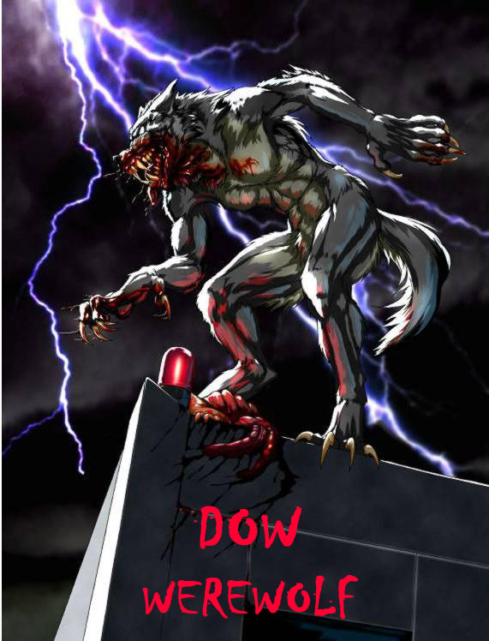
Name : Type : werewolf

WP | 0
WK | 0
CQ | 8
ST | 8
FT | 10
HP | 10
AR | 0
ML | 10
CC | 5

10 | 9 | 8 | 7 | 6 | 5 | 4 | 3 | 2 | 1 | KO | -1 | -2 | -3 | -4 | -5 | -6 | -7 | -8 | -9 | KIA

CLAWS : DPR 4 ARM –3
TEETH : DPR 2 ARM -2
Bite = 4 + werewolf strength – opponent’s strength
Parry : 4
Walk : 1/1” Run : 2/5” Run in rubble : 4/5” Crawl : 1/1” Climb : 1/1” Stand from prone : 2 Stand from crouch : 1 Jump : 1 AP/inch. 4 inches max.Always ignore battle fatigue checks due to running.

Name : Type : werewolf

WP | 0
WK | 0
CQ | 8
ST | 8
FT | 10
HP | 10
AR | 0
ML | 10
CC | 5

10 | 9 | 8 | 7 | 6 | 5 | 4 | 3 | 2 | 1 | KO | -1 | -2 | -3 | -4 | -5 | -6 | -7 | -8 | -9 | KIA

CLAWS : DPR 4 ARM –3
TEETH : DPR 2 ARM -2
Bite = 4 + werewolf strength – opponent’s strength
Parry : 4
Walk : 1/1” Run : 2/5” Run in rubble : 4/5” Crawl : 1/1” Climb : 1/1” Stand from prone : 2 Stand from crouch : 1 Jump : 1 AP/inch. 4 inches max.Always ignore battle fatigue checks due to running.

Name : Type : werewolf

WP | 0
WK | 0
CQ | 8
ST | 8
FT | 10
HP | 10
AR | 0
ML | 10
CC | 5

10 | 9 | 8 | 7 | 6 | 5 | 4 | 3 | 2 | 1 | KO | -1 | -2 | -3 | -4 | -5 | -6 | -7 | -8 | -9 | KIA

CLAWS : DPR 4 ARM –3
TEETH : DPR 2 ARM -2
Bite = 4 + werewolf strength – opponent’s strength
Parry : 4
Walk : 1/1” Run : 2/5” Run in rubble : 4/5” Crawl : 1/1” Climb : 1/1” Stand from prone : 2 Stand from crouch : 1 Jump : 1 AP/inch. 4 inches max.Always ignore battle fatigue checks due to running.

