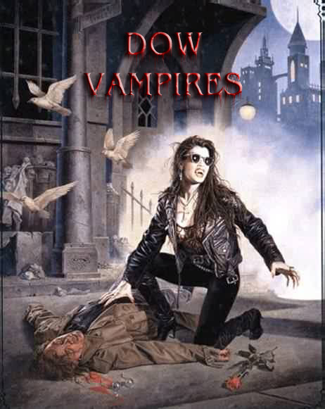

Version 1.0
By Eric LAURENT and totally inspired by Scott Kirby DOW HOUNDS of HELL rules)

These rules are a modification of DOW rules to play vampires.

They are meant to be played with the DOGS OF WAR basic rules published by DEVIL DOG DESIGN.

Vampire cost : 110 points

Abilities
WP: Weapon Proficiency 6
WK: Weapon Knowledge 5
CQ: Close Quarters Combat 7
ST: Strength 7
FT: Fortitude 7
HP: Health 10
AR: Armor Rating (with body armor and helmet) 0
ML: Morale 8
CC: Command & Control 8/LOS

Innate Abilities AND SPECIAL RULES

NIGHT VISION

Vampires are night creatures and can see in the dark as in daylight.

Movement

Vampires are unnaturally swift and fast creatures. They always ignore battle fatigue tests and halve all AP cost for movement.

DOMINATION (AP5)

Vampires are masters of mind control and persuasion. They may attempt to mentally attack a human being. (cost AP5, range 6”, target must make a morale test or fall under the vampire player control for one turn).

NO REFLECTION

Vampires cast no reflection.This provides an ability to be undetectable to night vision goggles, infrared detection and the like. They can only be seen with the naked eye.

TELEPORTATION (SPELL - AP6)

Vampires using this spell can move very quickly. They can spend 6 AP to teleport up to 2D10 inches. Movement can pass through terrain items but cannot end in them (eg a wall).

SHOOTING AT VAMPIRES

Shooting at a moving vampire is difficult : -2 to hit modifier.

DODGE ATTACK (SPELL - AP3)

This spell gives the vampires an equivalent AR of 5 for all hit locations. It lasts for 1 turn and represents the vampire dodging blows and even bullets (a kind of “Matrix” mode). This spell does not protect from blast effects.

VAMPIRE KISS

In order to bite his the vampire must roll less or equal to the bite result with a single D10 :

Bite = 3 + vampire strength – opponent’s strength

If the bite is a success, the victim will lose 2 HP and the vampire can regain 1 HP (if he his wounded. Up to the initial maximum of 10).

The vampire will have to re-roll each turn otherwise the victim will escape (except if it is KO).

If the victim is dominated, no roll is required at all.

The vampire can drink blood until the human being dies (0 HP).

FEAR

Vampires cause fear.

* In addition to the morale rules in the rulebook, if a human witnesses a friend killed, he must make a shell shock morale test, with a -1 for every friendly human that has been killed up to this point in the game.

* When a vampire enters base/CQ combat with a human, the human must take a morale test.

* When a human enters base/CQ combat with a vampire, the human must take a morale test.

Once a human has passed this test, the test doesn’t need to be taken again.

HEALTH AND DAMAGE

Vampires are immune from most physical diseases because…they are dead.

They can, therefore, be virtually immortal and live centuries. However, they can be killed by any wound that destroys the heart, or any form of death that causes heart damage.

We can assume (for game purposes) that a beheaded vampire will die too.

Holy water (on weapons or bullets for example) doubles damage (DPR is boubled).

On a Head or Chest damage result of 1 or less, the vampire is instantly killed, even with ordinary weapons.
Vampires are vulnerable to sun light and will be instantly killed if exposed to sun light.

Vampires recover from immobilized or unconscious results when they regain health points.

BECOMING A VAMPIRE

A human bitten by a vampire will transform into a vampire when he fails a fortitude test. Roll each turn (with a -1 modifier each turn : -1 second turn, -2 third turn, ….).

This rule should only be used for campaigns.

Name : Type : vampire

WP | 6
WK | 5
CQ | 7
ST | 7
FT | 7
HP | 10
AR | 0
ML | 8
CC | 8

10 | 9 | 8 | 7 | 6 | 5 | 4 | 3 | 2 | 1 | KO | -1 | -2 | -3 | -4 | -5 | -6 | -7 | -8 | -9 | KIA
Bite = 4 + vampire strength – opponent’s strength

DOMINATION : AP5 range 6” (ML test for target)

TELEPORTATION : AP6 range 2D10”

DODGE ATTACK : AP3

Name : Type : vampire

WP | 6
WK | 5
CQ | 7
ST | 7
FT | 7
HP | 10
AR | 0
ML | 8
CC | 8

10 | 9 | 8 | 7 | 6 | 5 | 4 | 3 | 2 | 1 | KO | -1 | -2 | -3 | -4 | -5 | -6 | -7 | -8 | -9 | KIA
Bite = 4 + vampire strength – opponent’s strength

DOMINATION : AP5 range 6” (ML test for target)

TELEPORTATION : AP6 range 2D10”

DODGE ATTACK : AP3

Name : Type : vampire

WP | 6
WK | 5
CQ | 7
ST | 7
FT | 7
HP | 10
AR | 0
ML | 8
CC | 8

10 | 9 | 8 | 7 | 6 | 5 | 4 | 3 | 2 | 1 | KO | -1 | -2 | -3 | -4 | -5 | -6 | -7 | -8 | -9 | KIA
Bite = 4 + vampire strength – opponent’s strength

DOMINATION : AP5 range 6” (ML test for target)

TELEPORTATION : AP6 range 2D10”

DODGE ATTACK : AP3

